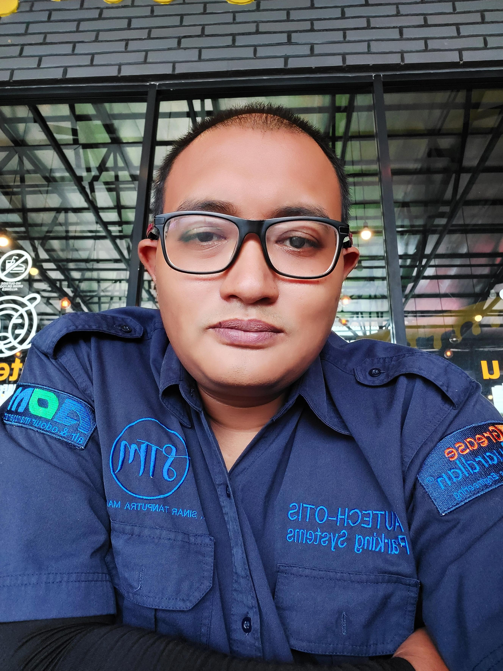 | CURRICULUM VITAE
 | Korean |  | 아프린도 |  | 연 락 처
 | English |  | AFRINDO |  | +6281212066691(whatsapp)  +6285210116227, afrindo16 (kakao talk)
 | Email |  | andante830416@gmail.com
address | jl jagakarsa 1 kav 5g jagakarsa jakarta selatan(남부 자카르타)
학 력 사 항
Periode studi |  | Nama Sekolah |  | Jurusan |  | Remark
1998년-2001 |  | SLA PURWODADI(High School)
-
-
실무 경력사항
Work periode |  | Work Place |  | Position |  | Reason for leaving
Year 2005 to 2007 |  | Issac toast front of Seoul HUFS south Korea |  | sales |  | Change of business owner
Year 2007 to 2010 |  | ZZang Internet Caffee front of Seoul HUFS south Korea |  | Manager
Year 2010 to 2013 |  | Gangbyeon Techno Mart KT Agency South Korea |  | Sales |  | Back to indonesia
Year 2014 to 2020 |  | DMIC Crusher Jakarta Indonesia |  | field interpretation work Freelance |  | Pandemic
April 2021(6 months) |  | Otek Otis Parking sistem Jakarta Indonesia |  | field interpretation work Freelance |  | contract expiration
February 2022 (2-week project) |  | HYUNDAI MOTOR MANUFACTURING I INDONESIAMANUFACTURING INDONESIA |  | field interpretation work Freelance |  | contract expiration
Other professional experience
Work periode |  | Work Place |  | Position |  | Reason for leaving
May 2022 - July 2022 |  | CJ Cheil Jedang freelance Jakarta Indonesia |  | Freelance interpreter for the diagnostic (Auditor) team |  | contract expiration
2 weeks in August 2022 |  | Daesang Miwon company located in Jakarta, Indonesia |  | Freelance interpreter for the diagnostic( Auditor) team |  | contract expiration
November 4, 2023 - March 28, 2024 |  | 인도(India) Parking system |  | Freelance Project Manager |  | contract expiration
April 12, 2024 - May 5, 2024 |  | CJ LOGISTIC SERVICES INDONESIA |  | Freelance interpreter for the diagnostic( Auditor) team |  | contract expiration
June 2024 - October 2024 |  | CJ Food Lestari Indonesia |  | Machine installation and interpretation for Korean technicians |  | contract expiration
February 2025 (3day) |  | PT DETPAK INDONESIA |  | Machine installation and interpretation for Korean technicians |  | contract expiration
November 2024 (3day) |  | Korea Testonic |  | exhibition interpreter |  | contract expiration
November 2024 (3day) |  | ( B&E ) Dental |  | exhibition interpreter |  | contract expiration
December 2024 (3day) |  | ATC INTERNATIONAL |  | business meeting |  | contract expiration
Additional information | I will be a person who works hard and is responsible.
The above-mentioned information is correct and accurate.

Year month Day

applicant : Afrindo (인)

Personal statement
Personal development
Hello, I am Afrindo, a local interpreter. I was born on April 16, 1983. I am the second of two siblings. I am currently 41 years old. Riding motorcycles and traveling is my hobby. From 2002 until the end of 2013, I lived in South Korea and gained a lot of experience, both in terms of work and personal life

school years
During my school years, I wasn't particularly fond of studying, but I attended school well. I don't like fighting, but I joined the boxing club and basketball club for my health. I really liked making jokes at school, so I have many friends.

personality introduction
I am the type of person who works hard, and helping those in need is part of my personality.

